**DESIGN AGENCY**

**Aim**  
 To design a contact page layout for a design agency, showcasing office locations on a global map, and including address details in an organized structure.

**Procedure:**

1. Set up a 1920x1080 canvas for web design.
2. Add a header with the agency logo and navigation links.
3. Design a section with address boxes for each office location.
4. Place a world map as the background for the lower section.
5. Add markers and labels for studio locations on the map.
6. Create a "Global Footprints" section with project details and locations.
7. Style the layout with consistent fonts, colours, and alignment.

**Diagram:**

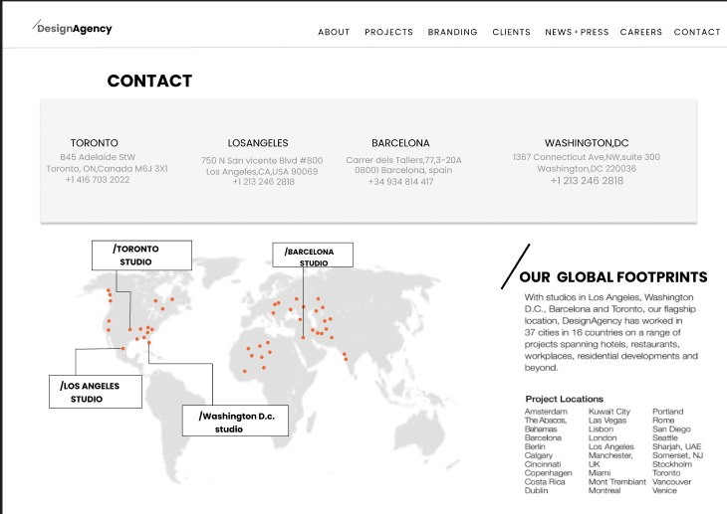

**Result:**

The contact page layout for a design agency is designed successfully.